

# January 6, 2023

**Sub: Revision of Joining Date**

# Dear Sandhya Ajinath Karkhele,

This is with reference to our offer of employment Ref LTIMindtree/HRDIGITAL ENGINEERING/2426430 dated November 2, 2022.

As discussed, your date of joining has been extended. You are now required to join at our Shivaji Nagar Office on or before January 11, 2023.

All other terms & conditions of our offer of employment remain unchanged.

Please confirm your acceptance of these terms by signing on the duplicate copy of the letter and return the same back to us.

# Yours faithfully,

**LTIMindtree Limited**

# (Formerly Larsen & Toubro Infotech Limited)



**Rajeev Yadav**

# Senior Director - Talent Acquisition

I have read the above contents and accept the same.

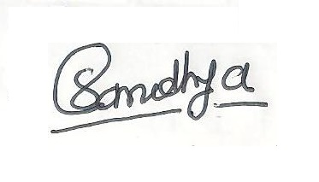

# Signature and Date Date Of Joining

**Sandhya Ajinath Karkhele**

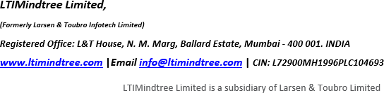

Page 1 of 1